**Graph Theory (Wheel N-Cube)**

**Wheel**

Adding an additional vertex to the cycle *Cn*. for n>3, and connecting this new vertex to each of the n vertices in *Cn* by new edgs we obtain a graph which is called wheel. It is denoted by *Wn*.

A wheel graph W_n of order n, sometimes simply called an n-, is a graph that contains a [cycle](http://mathworld.wolfram.com/CycleGraph.html) of order n-1, and for which every [graph vertex](http://mathworld.wolfram.com/GraphVertex.html) in the cycle is connected to one other [graph vertex](http://mathworld.wolfram.com/GraphVertex.html) (which is known as the [hub](http://mathworld.wolfram.com/Hub.html)). The edges of a wheel which include the [hub](http://mathworld.wolfram.com/Hub.html) are called spokes. The wheel W_n can be defined as the graph K_1+C_(n-1), where K_1 is the [singleton graph](http://mathworld.wolfram.com/SingletonGraph.html) and C_n is the [cycle graph](http://mathworld.wolfram.com/CycleGraph.html). Note that there are two conventions for the indexing for wheel graphs that W_n denotes the wheel graph on n+1 nodes.

Examples of wheel graphs:

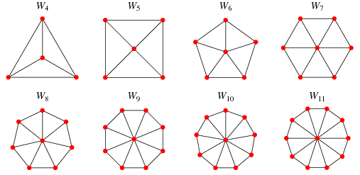

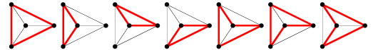

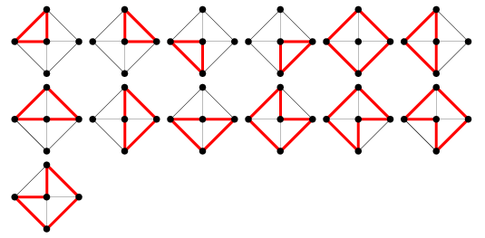

The number of [graph cycles](http://mathworld.wolfram.com/GraphCycle.html) in the wheel graph W_n is given by n^2-3n+3, or 7, 13, 21, 31, 43, 57, ... for n=4, 5, ....

In a wheel graph, the [hub](http://mathworld.wolfram.com/Hub.html) has [degree](http://mathworld.wolfram.com/Degree.html) n-1, and other nodes have degree 3. Wheel graphs are 3-connected. W_4=K_4, where K_4 is the [complete graph](http://mathworld.wolfram.com/CompleteGraph.html)of order four. The [chromatic number](http://mathworld.wolfram.com/ChromaticNumber.html) of W_n is

|  |  |
| --- | --- |
| chi(W_n)={3   for n odd; 4   for n even. | (1) |

The wheel graph W_n has [chromatic polynomial](http://mathworld.wolfram.com/ChromaticPolynomial.html)

|  |
| --- |
| pi(x)=x[(x-2)^(n-1)-(-1)^n(x-2)]. |

**n-Cube:**

The graph that has vertices representing the 2n bit string of length n is calle the n-dimensional cube or n-cube. It is denoted by *Qn*. The graph *Q1*, *Q2*, *Q3*, *Q4* are :

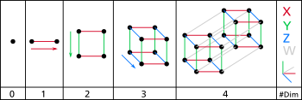

**Generalization**

**0** – A point is a hypercube of dimension zero.

**1** – If one moves this point one unit length, it will sweep out a line segment, which is a unit hypercube of dimension one.

**2** – If one moves this line segment its length in a [perpendicular](https://en.wikipedia.org/wiki/Perpendicular) direction from itself; it sweeps out a 2-dimensional square.

**3** – If one moves the square one unit length in the direction perpendicular to the plane it lies on, it will generate a 3-dimensional cube.

**4** – If one moves the cube one unit length into the fourth dimension, it generates a 4-dimensional unit hypercube (a unit [tesseract](https://en.wikipedia.org/wiki/Tesseract" \o "Tesseract)).

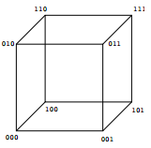

**Elements of n-Cube**

Every n-cube of n > 0 is composed of elements, or n-cubes of a lower dimension, on the (n-1)-dimensional surface on the parent hypercube. A side is any element of (n-1) dimension of the parent hypercube. A hypercube of dimension n has 2n sides (a 1-dimensional line has 2 end points; a 2-dimensional square has 4 sides or edges; a 3-dimensional cube has 6 2-dimensional faces; a 4-dimensional tesseract has 8 cells). The number of vertices (points) of a hypercube is 2^{n} (a cube has 2^{3} vertices, for instance).

The number of *m*-dimensional hypercubes (just referred to as m-cube from here on) on the boundary of an *n*-cube is

 E_{m,n} = 2^{n-m}{n \choose m} ,   where {n \choose m}=\frac{n!}{m!\,(n-m)!}and *n*! denotes the [factorial](https://en.wikipedia.org/wiki/Factorial) of *n*.

For example, the boundary of a 4-cube (n=4) contains 8 cubes (3-cubes), 24 squares (2-cubes), 32 lines (1-cubes) and 16 vertices (0-cubes).

This identity can be proved by combinatorial arguments; each of the 2^n vertices defines a vertex in a m-dimensional boundary. There are {n \choose m} ways of choosing which lines ("sides") that defines the subspace that the boundary is in. But, each side is counted 2^m times since it has that many vertices, we need to divide with this number.

This identity can also be used to generate the formula for the n-dimensional cube surface area. The surface area of a hypercube is:  2ns^{n-1} .

These numbers can also be generated by the linear [recurrence relation](https://en.wikipedia.org/wiki/Recurrence_relation)

E_{m,n} = 2E_{m,n-1} + E_{m-1,n-1} \!,     with E_{0,0} = 1 \!,     and undefined elements (where m < n, m < 0, or n < 0) = 0.

For example, extending a square via its 4 vertices adds one extra line (edge) per vertex, and also adds the final second square, to form a cube, giving E_{1,3} \! = 12 lines in total.

